Legacy Farms
Volunteer Information Packet
PATRICK COX
9/25/2015

Table of Contents

Welcome to Legacy Farms………………………………………..1

Seeding Virginia with Hope………………………………………..4

Volunteer Opportunities……………………………………………6

Volunteer Application………………………………………………7

Volunteer Agreement………………………………..……………10

Background Consent and Release Form….…………………..11

Confidentiality Agreement……………………………………….12

Photo and Press Release Form…………………………………..13

Emergency and Medical Information………………………….14

Welcome to Legacy Farms

We appreciate you donating your time and efforts to enhance the lives of those we serve at Legacy Farms. A volunteer is a key position in our organization and a great opportunity to gain valuable experience in agriculture, event and fundraising management, and off course working with the special needs community. We are very excited to have you on board and look forward to working alongside you as help those in need. If there is a particular area of interest you would like to specifically focus on, please bring it to our attention. We want to ensure you are working in a role you are comfortable with and one that is consistent with your personal, academic and career goals.
Legacy Farms is a nonprofit, green care social venture dedicated to providing support services and agrarian based vocational training for adults with Autism, as well as those with other developmental and social challenges.
We rely heavily on our board, advisory committee and volunteers to ensure we are meeting the growing vocational needs of adults with autism, therefore by volunteering you are now part of a team of highly dedicated individuals who are not afraid to get our hands dirty, literally.
Martha explaining to an intern how to determine if the garden needs to be watered.

The Summer Garden
The 5 week “Summer Garden Project” ran from 10-noon every Tuesday thru Friday and each week we spent on a different topic:
- Week 1: We focused on safety in the garden and spent time generalizing the interns to their settings.
- Week 2: We spent time on garden maintenance, weeds and watering.
- Week 3: We taught The Lifecycle of a plant.
- Week 4: We explained how to judge when a vegetable is ready for harvest and began harvesting a portion of the garden.
- Week 5: We put it all together and started another garden at a local school.

Currently, we are operating out of Temple Hall Farm in Leesburg, Virginia. They have provided us 1/3 of an acre which we have used to create an “Outdoor Classroom”. Here we began our pilot program, “The Summer Garden Project”. Our goal was to create a program that would do three things:
- Provide a teaching garden for adults with autism, as well as those with developmental and social challenges.
- Raise awareness of our cause by demonstrating our participant’s skills, while educating the public about autism and the need for more vocational solutions.
- Improve community resiliency through gardening education programs, workshops and a hands-on demo garden highlighting a variety of gardening techniques.
The “Summer Garden Project” was a complete success. We worked with 18 interns from all over the county. We had a group from Echo, several students from Loudoun County Public Schools and several families who were very excited to have a program that would help their adult child learn new skills. As of September we have successfully aided in the employment of 3 adults who completed our program.
That is just the beginning…
The 2016 Summer Garden Project is just around the corner as well as several other learning opportunities we will be offering. We are excited you want to be a part of the team and we look forward to working with you at Legacy Farms!

The Volunteer Packet
In this packet you will learn a little more about the work we are doing, and WHY we feel it is so important. We ask that you fill out the following pages and return them to the Volunteer Coordinator, Michelle Lautenschlager or visit our website at www.AutismInLoudoun.org to obtain a copy. Once all the paperwork is completed and verified, you will be asked to complete a Volunteer Orientation Session.
The Volunteer Coordinator will schedule a time for you to attend one of the Volunteer Orientation Sessions.
Contents of the packet include:
1. Volunteer Application
The application must be signed (in ink), dated and witnessed. A copy of your current
Driver’s license is required for processing.
2. Volunteer Agreement
The agreement must be signed (in ink) and dated.
3. Background Consent and Release
The release must be signed (in ink), dated and witnessed.
4. Confidentiality Agreement
The agreement must be signed (in ink), dated and witnessed.
5. Emergency Contact Info
The agreement must be signed (in ink), dated and witnessed

If you have any questions or concerns, please feel free to contact the Volunteer Coordinator.
Michelle Lautenschlager
Volunteer Coordinator
703-728-7788
Please email copies to L13mamax2boys@gmail.com and info@legacyfarmsvirginia.org
Ian and Gavin hard at work defoliating at Tarara Winery
Jacob’s first day on the job at Sunset Hills Vineyard

Seeding Virginia with Hope

Every year, 50,000 adults with Autism Spectrum Disorder (ASD) transition out of high school and into the workforce, yet the unemployment rate grows faster than any other disability. It seems there is a major disconnect when it concerns adults with ASD and employment, and the resources needed to help are limited. Currently there are 3 local organizations dedicated to providing vocational services in Loudoun County:
  - The Arc of Loudoun
  - Department of Aging and Rehabilitative Services
  - ECHOworks
Each organization provides a wide range of services and they have helped thousands of families find jobs in the retail, direct mail, and providing office and warehouse assistance, but as autism becomes more prevalent in today’s society (1 in 68 children as of 2014), the need for more services grows.
  - 32.5% of young adults with autism spectrum disorders currently worked for pay versus an average of 59.0% for all respondents (all other disabilities). Only one disability group had a lower rate of employment participation.
  - 47.7% of youth with autism spectrum disorders worked for pay in the past two years versus an average of 78.4% for all participants.
  - 29.0% of young adults with autism spectrum disorders were looking for work if they were unemployed compared to 47.7% for all participants.
One reason for this is the lack of support services for adults with autism. Once they leave High School and turn 22, many of the services they have come to rely on are no longer available. Compound this with the lack of understanding the public has regarding how to work with people with autism and you have the answer-people just don’t know how to work with people who have such a diverse range of emotional, social, and sensory issues.
That’s where we try to help…
Our “Seeding Virginia with Hope” campaign is dedicated to working with the local agricultural industry to see how we can come together and create new jobs, beginning with Loudoun County.
We realize this is a very ambitious goal, however in order to make change sometimes it takes a more enterprising approach to raise awareness and get people talking. We hope that by beginning this campaign we will turn heads and get people working on other solutions as well.
To accomplish our goal, we have created the “Summer Garden” so we can demonstrate our skills and share the work we are doing with the community.
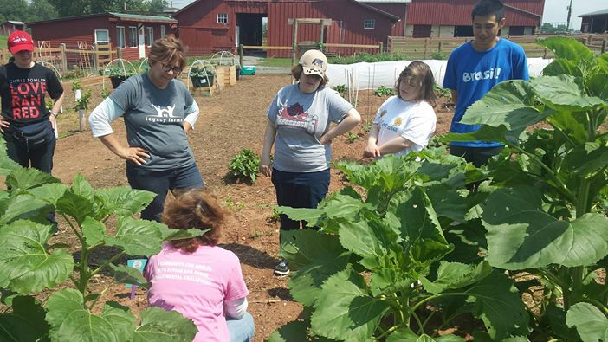

Did you know?
- Over the next 8 years it is estimated that over half a million children will be diagnosed with autism. That’s approximately 1 in every 68 children.
- 2 million Americans today are believed to have some form of autism, including the potential for there to be an excess of 125,000 Virginians.
- As of 2012 there were 1087 students in Loudoun County School System with Autism.
- More children will be diagnosed with autism this year than with AIDS, diabetes & cancer combined.
- Autism is the fastest-growing serious developmental disability in the U.S..
- While there is no medical detection or known cure for autism, thousands of children have shown significant improvement resulting from early diagnosis and use of effective interventions.
- The therapeutic benefits of life and work on a farm have been studied and documented for years. Along with its safer, quieter environment with less sensory challenges; a farm gives adults with developmental disabilities a chance to do meaningful, purposeful work, which creates a sense of accomplishment.

Volunteer Opportunities
There are many ways you as a volunteer can help us succeed at fulfilling our goals. We want you to hone in on your own experience and knowledge and put it to use, and we have plenty of needs that need to be fulfilled so you can do just that…
- Garden/Farm Team: Our Garden at Temple Hall Farm has the potential of operating 3 of 4 seasons, the only thing holding us back are people to man it. We need a dedicated gardening team to plan, plant, maintain, harvest and plan again so we will have an amazing workspace for years to come.
- Garden Assistant: We have multiple gardens around the area, and they need watered and maintained. As a garden assistant your role will be to ensure these gardens are being tended to in the best way possible. We need multiple people to fill this role, that way they aren’t running out every day.
- Information Booth Ambassadors: As we continue to grow, we will attend many events in the future. This is a great opportunity for people interested in the event management and public relations fields to gain valuable experience. Our “Information Ambassadors” will be out in the field sharing our stories and engaging with the community.
- Event/Fundraising Team: Although all volunteers are equally important, the event/fundraising team is essential to success. As a nonprofit we rely heavily on donations and we hope to really start pushing our fundraising and monthly giving campaigns. Those seeking to volunteer for a role on this team must have experience in the field.
- Business/Administrative/Finance: As a working Board of Directors, we have a lot on our plate, and we could use some help when it comes to the business side of things. Our treasurer is looking for someone to help her with financials, the secretary could use help with notes, and we are working overtime building new relationships and sending emails. We could use a lot of help in this area, so if you have experience in business, business management, sales or finance we would love to talk.
- Job Coaches and Training Team: If your interest lies solely in helping our interns, than we have plenty of work for you. Whether it’s helping in the garden, or on a potential job site your skills are vital to the team. This is also a great position for people looking to work with developmentally challenged individuals.
- Marketing/Public Relations: Are you great with people? Do you have a knack for inspiring others? Are you a photographer, videographer, or love to write? Our marketing team has many options for you to excel at what you do and help Legacy Farms raise awareness of our cause.
- You: On many occasions people just want to help. They don’t have any particular skill or need behind why they want to help, they just do. Or perhaps they have a variety of skills, but don’t want to be clumped into one specific category, if this is you we have plenty of need for your help.

Volunteer Application

Contact Information
Name______________________________________________________________
Address: ____________________________City_______________State__________Zip_________
Telephone: Home ( ) _____________________Work ( ) _______________ (Cell)_________
Email::___________________________Employer__________________________________________

Availability
During which hours are you available for volunteer assignments?
Weekday mornings (10:00 A.M.-2:00 P.M.) Weekday afternoons (2:00 P.M.-6:00 P.M.)
Weekend mornings (10:00 A.M.-2:00 P.M.) Weekend afternoons (2:00 P.M.-6:00 P.M.)
Check the area you are interested in volunteering:
Temple Hall Farm Offsite Garden Projects
Fundraising/events Administration
Finance Grant Writing
Curriculum Working with interns
Video/Photography Newsletter/Blogging

Special Skills or Qualifications
Check any special skills and qualifications you have acquired from employment, previous volunteer work, or through other activities, including hobbies or sports:

Agriculture/Gardening
Teaching/Training
Special Education
Marketing/Public Relations
Fundraising/Event Planning
Autism Advocacy
Finance/Management
Administration

Previous Volunteer Experience
Please summarize your previous volunteer experience: _____________________________________________________________________________________________________________________________________________________________________________________________________________________________________________________________________________________________________________________________________________________________________________________________________________________________________________________________________________________________________________________________________________________________________________________________________________________________________________________________
Do you have any physical or mobility limitations? YES _____ NO _____ (If yes, please explain): ______________________________________________________________________________________________________________________________________________________________________________________

Person to Notify in Case of Emergency
Name ______________________________________________________________________________
Street Address _______________________________________________________________________
City/State/Zip ________________________________________________________________________
Home Phone ____________________________ Cell Phone __________________________________
Work Phone _________________________________________________________________________

Agreement and Signature
By submitting this application, I affirm that the facts set forth in it are true and complete. I understand that if I am accepted as a volunteer, any false statements, omissions, or other misrepresentations made by me on this application may result in my immediate dismissal.
Name (printed) ____________________________________________________________________
Signature __________________________________________________________________________
Date ______________________________________________________________________________
  - Our Policy
It is the policy of this organization to provide equal opportunities without regard to race, color, religion, national origin, gender, sexual preference, age, or disability.
Please attach a photocopy of your current Driver’s License to this form. Please fill out and sign the Background Consent and Release form. This information is collected for your safety as well as that of Legacy farms. We will keep your private information in a safe and secure location. This information will not be sold, or disclosed to any third party.
Thank you for completing this application form and for your interest in volunteering with Legacy Farms Virginia. Please feel free to contact the Volunteer Coordinator with any questions or concerns at 703-728-7788.
Name______________________________________________________________________________Date________________________

Volunteer Agreement
As a Legacy Farms Volunteer, you agree to the following:
- Be on time.
- If you cannot volunteer at your scheduled time, please notify the Volunteer Coordinator as far in advance as possible.
- Please do not consume alcohol or other drugs before or while volunteering at Legacy Farms.
- Leave valuables at home or locked out of sight in your car.
- Dress accordingly.
- Notify the Volunteer Coordinator when bringing an unscheduled guest. For safety reasons, please do not bring children under the age of 16 to the garden, unless they are supervised by another parent or guardian.
- To avoid discriminating against anyone’s religious beliefs, religious instruction and the observance of any group practices are prohibited at Legacy Farms.
- Please direct problems, questions, or suggestions to the Volunteer Coordinator.
- Volunteers may be dismissed by the Volunteer Coordinator or Board Member for poor attendance, poor performance or for actions, with warning, contrary to Legacy Farms policies and procedures.

Volunteering in the Garden
- Volunteers are to sign in and out every time they work in the garden. This is to provide Temple Hall Farm and Legacy Farms with proper volunteer record keeping.
- For reasons of liability, volunteers are not to give interns rides in their personal vehicles unless accompanied by job coach or service provider. Legacy Farms takes no responsibility for accidents occurring when volunteers do not follow this policy.
- Volunteers should each fill out a Personal Data Sheet inside the Legacy Farms notebook.
- All tools are to be stored in shed. There are extra gloves, gardening tools and supplies available to volunteers, but we suggest each garden volunteer provide their own gloves, clippers and garden trowel.
- ALWAYS ensure the water is turned off at the end of the day.
- Volunteers should show up ready to work:

  - Long pants and t-shirt
  - Work boots
  - Hat
  - Sunscreen/Bug Repellant
  - Gloves
  - Plenty of water

By signing below, I signify that I have read and understand the Volunteer Agreement stated above and will abide by the policies and procedures of Legacy Farms Virginia.
Name _____________________________________ Date___________________

Background Consent and Release Form

I understand that, as a condition of my consideration to provide volunteer services at Legacy Farms, or as a condition of my continued volunteer service with Legacy Farms. Legacy Farms may obtain a background report that includes, but is not limited to, my criminal and civil history, personal interviews, DMV records, any other public records and any other information bearing on my, character, general reputation, personal characteristics and trustworthiness.
I hereby authorize and consent to Legacy Farms procurement of such a report. I further understand that the information in said report will be made available to me prior to any decision being made, along with the name and address of the reporting agency that produced said report.
Have you ever been convicted of a crime other than a minor traffic violation? Yes No
If yes, please explain:
______________________________________________________________________
______________________________________________________________________
Driver’s License Number: _________________ State: ______ DOB: _____/____/____
I affirm that, to the best of my knowledge, the information on this application is correct.

Print Name _____________________________________________ Date _________
Signature of Volunteer Applicant __________________________ Date _________
Witness Signature ________________________________________ Date _________

Volunteers may be dismissed by the Volunteer Coordinator or Board Member for poor attendance, poor performance or for actions, with warning, contrary to Legacy Farms policies and procedures.

Confidentiality Agreement

I understand that I may recognize person(s) who are receiving services at Legacy Farms. I further understand that I may have access to information (verbal, written, experience or otherwise) that will pertain to persons who are receiving or have received services at Legacy Farms Virginia and that the Legacy Farms program and any information regarding a client served at Legacy Farms is protected by the confidentiality regulations (10 NCAC 18D APSM 45-1) as developed by the division of Mental Health, Mental Retardation, Development Disabilities and Substance Abuse Services which ensure the privileged and confidential nature of client information.
My signature below signifies that I have read the attached confidentiality regulation and acknowledges my understanding of the strict confidential nature of information at Legacy Farms. I agree not to disclose any information, including but not limited to, the knowledge of any client.
I further understand that the divulging of confidential information to unauthorized persons will make me subject to civil action.

Signed _________________________________________ Date ___________________

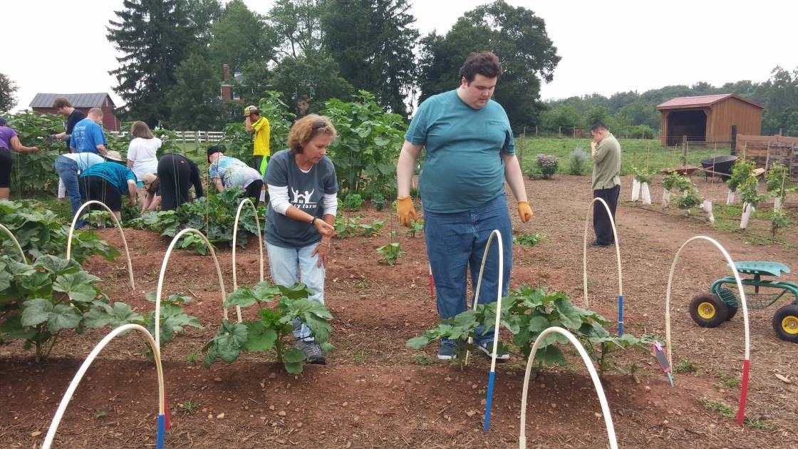

Photo and Press Release Form
On many occasions we love to show off the work our volunteers and interns are engaging in and we are well represented on social media. This simple consent form allows us to use your image on social media, marketing material, media and press releases, and posters to be used at events or in schools and institutions.
I authorize Legacy Farms to use my name, statements and likeness, without charge, for promotional purposes in publications, advertising, video, web, new media, or other formats.
Name: ______________________________________________________________________________
Signature: ___________________________________________________________________________
E-mail: ______________________________________________________________________________
Phone: ______________________________________________________________________________
Address: ____________________________________________________________________________

If under 18, parent name and service provider signature also required:
Parent Name: ________________________________________________________________________
Service Provider: _____________________________________________________________________
Organization: _______________________________________________________________________
Address: ____________________________________________________________________________
Phone: ______________________________________________________________________________
Signature: ___________________________________________________________________________

“Whenever there is a human need, there is an opportunity for kindness and to make a difference.”

Emergency and Medical Information

I, _________________, hereby grant Legacy Farms Virginia, of PO Box 4499, Leesburg, Virginia 20176, the authority to obtain medical treatment for the following child(ren):

Name of Child: _________________
Birthdate: _________________

The above care provider(s) are authorized to:
- obtain medical treatment and procedures for the child(ren) as may be appropriate in emergency circumstances, including treatment by physicians, hospital and clinic personnel, and other appropriate health care providers.
This grant of temporary authority shall begin on January 01, 2017, and shall remain effective until terminated by the undersigned.
In case of an emergency, the care provider(s) should first try to contact the parent(s). If the parent(s) cannot be reached, the care provider should then contact the following person(s) in the order listed below:
Name: _________________
Relationship to Child: _________________
Address: ______________________________, _________________, _________________ _________________
Place of Employment: _______________________________
Preferred Phone Number: _______________________________
Alternate Phone Number: _______________________________

If the child(ren) become ill, the care provider(s) will first try to contact the parent(s). If the parent(s) cannot be reached, the care provider should contact the following physician:

Name of Physician: ____________________________________
Address: __________________________________________
_________________, _________________ _________________
Phone Number: _________________

If the child(ren) need hospitalization, the preferred choice is:
Hospital preference: _________________
Address: ___________________________________________
_________________, _________________ _________________

Please attach most recent shot records.
The care provider(s) may provide the physician and other health care providers with the following health insurance information:

Insurance Company: ______________________________________
Policy Number: ______________________________________
Name of Policy Holder: ____________________________________

Dated: _________________

Parent or Guardian Sign: _____________________________________________________________

Parent Address: _________________________________
_________________, _________________ _________________

Preferred Phone Number: _________________
Alternate Phone Number: _________________

